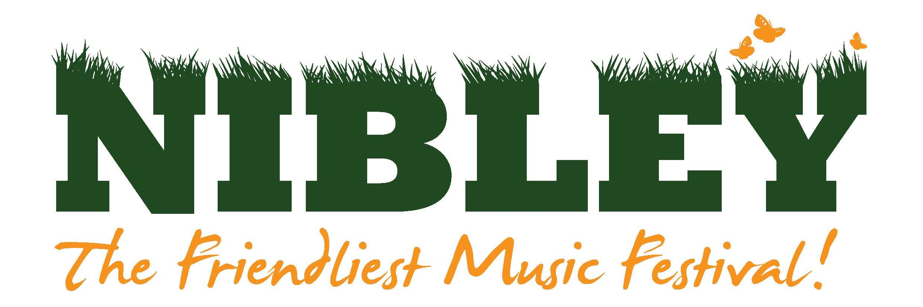

99 Merlin Way
Chipping Sodbury
Bristol
BS376XT

Dear Stallholder,

We look forward to your participation at this year’s festival:
Friday 3rd & Saturday 4th July 2020 at Nibley House Farm
North Nibley, Gloucestershire, GL11 6DL
We are a family festival and our main aim is to provide great music, food and entertainment in a friendly and safe environment. Any profit from the festival is donated to charity. The theme this year is Movies and it would be great if you could decorate your stall to suit the theme.
Please take the time to read the stallholder’s general information and health and safety guidelines. This will inform you of site access and trading times. Signing below shows your acceptance of them.

Pitches prices:
- 3x3m pitch + 1 adult ticket - £90
- 3x3m pitch + 2 adult tickets - £130

A sensible amount of additional tickets can be purchased at the selling price before the general sale if your application is successful. All tickets are valid for the whole weekend and camping.
Pitch prices also include one free car parking space and any additional can be purchased when applying for additional tickets.

Trading is compulsory for Saturday and optional for Friday however is encouraged as the main site is open and active. If you choose to trade on Friday, your stall must be ready to trade by 4PM for the gates to open at 5PM. Please indicate if you would like to camp on the application form. There is an additional charge for campervans.

It is very important that you have a strong, sturdy shelter to trade from. If you require one, we have them to hire for the weekend for £72 (inc VAT) that will be erected ready for you. Please indicate on the application form if this is required.

Please return the application form before Monday 3rd February 2020 by email (below) or post (above). Please note that due to demand we may not be able to accept all applications for stalls. PLEASE ANSWER EVERY QUESTION in detail! It is important to be very clear with what you will be selling, any stall requirements and the dimensions of your stall, even if you have traded with us previously.

Please indicate if you have any interactive elements to your stall with as much detail as possible.

Please DO NOT SEND any payment at this point.

Best Wishes,
Lauren Thomas
North Nibley Music Festival Committee
www.nibleyfestival.co.uk
thomaslauren000@gmail.com / 07950858007

Application Form 2020

Name of stall:

Nature of stall and details of merchandise:

Will you provide any interactive elements to your stall? (Please include as much detail as possible)

Details of Main Contact
Name:
Address:

Telephone No:
Mobile No:
Email Address:

Website or Facebook Page Name:

Insurance: Stallholders MUST have public liability insurance. Please supply details. We require proof of insurance with this application, this can be e-mailed or posted alongside this application. Applications will not be considered without it.
Please highlight which deal you will require:
- 3x3m pitch with 1 adult weekend ticket - £90
- 3x3m ptch with 2 adult weekend tickets - £130

Additional Information:
Do you want to hire a 3x3m gazebo to trade from, for £72 (inc VAT)?

Is there any other details we may need to know (EG. Do you require a pitch larger than 3 x 3m? Will you be camping or have a campervan?)

Please advise the type of vehicle you will be bringing to transport your stall (EG. Car, van etc.)

DO NOT SEND ANY PAYMENT AT THIS POINT. There will opportunity to purchase additional tickets once your application has been accepted in late February.

I agree to abide by the attached terms and conditions.

Signed:
Print name: Date:

