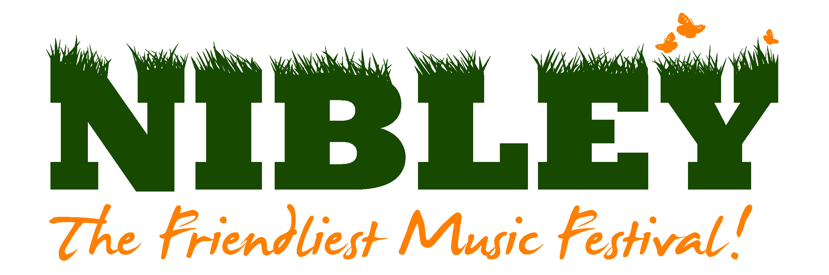
Deanfield
New Road
Dursley
Gloucestershire
GL11 6DR

Dear Stallholder
We look forward to your participation at this year’s Festival:
Friday 6th & Saturday 7th July 2018 at Nibley House Farm
North Nibley, Gloucestershire, GL11 6DL

We are a family festival and our main aim is to provide great music, food and entertainment in a friendly and safe environment. Any profit from the festival is donated to charity. This years theme is PIRATES and it would be great if you could decorate your stall to suit the theme.
Please take the time to read the stallholders terms and conditions. These tell you times you can access the site and when you can trade. Signing below shows your acceptance of them.
This year pitches are £90 (inc VAT) each and include two adult tickets and a 3x3m pitch. Alternatively, you can have the same pitch size with one adult ticket for £55 (inc VAT). A sensible amount of additional tickets can be purchased before the general sale if your application is successful.
Trading is for Saturday only, unless by special arrangement, All tickets are valid for the whole weekend and camping. Please indicate if you would like to camp on the application form. There is an additional charge for campervans.
It is very important that you have a strong, sturdy shelter to trade from. If you require one we have them to hire for the weekend for £60 (inc VAT) this will be erected ready for you. Please indicate on the application form if this is required.

Please return the application form before 19th February 2018 to the address above, or email as below. Please note that due to demand we may not be able to accept all applications for stalls. PLEASE ANSWER EVERY QUESTION! It is important to be very clear with your requirements and the dimensions of your stall. We will let you know if you are successful by early/mid March.
Please DO NOT SEND any payment at this point.

Thank you.
Carolyn Timbrell
Nibley Music Festival Committee
www.nibleyfestival.co.uk stalls@nibleyfestival.co.uk ph 01453 542494 07860110132

Application Form 2018

Name of stall:

Nature of stall and details of merchandise:

Name of main contact:
- Address:

- Telephone No:

- Mobile No:

- Email and/or website:
- Insurance: Stallholders MUST have public liability insurance. Please supply details. We require proof of Insurance with this application. Applications will not be considered without it.
- Cost (delete as appropriate)
I require a 3 x 3m pitch with 2 adult tickets, £90( inc VAT)
I require a 3 x 3m pitch with 1 adult ticket, £55 (inc VAT)
I would like to hire a 3 x 3m gazebo from the festival for £60 ( inc VAT)
DO NOT SEND ANY PAYMENT AT THIS POINT. There will opportunity to purchase additional tickets and camping pitches in early March.
- Any other information we may need to know: (eg if your pitch is larger than 3 x 3m)

- Please advise the type of vehicle you will be bringing e.g car, small van, large van

I agree to abide by the attached terms and conditions.

Signed:
Print name: Date:

