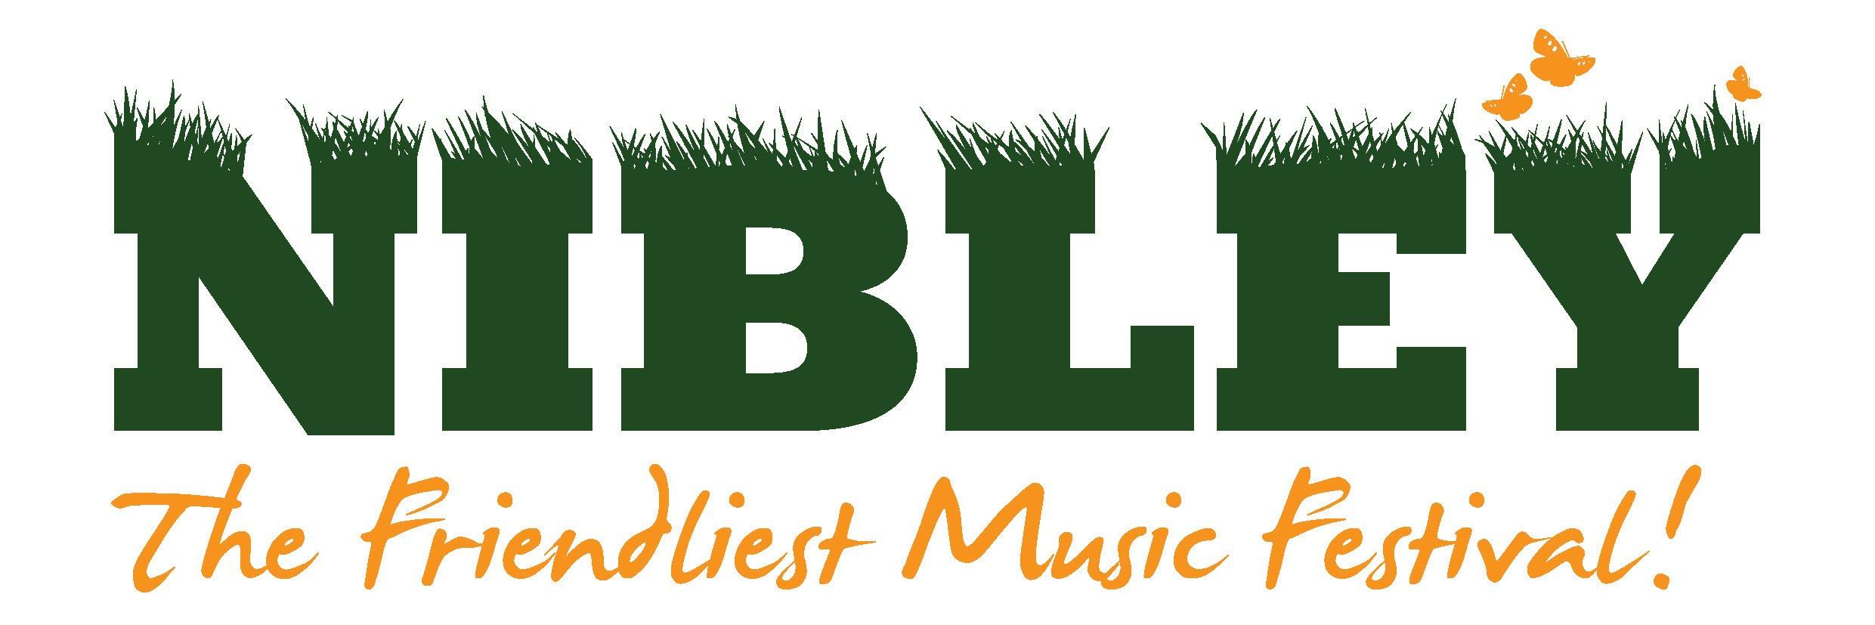
2 Gathorne Crescent, Yate, Bristol , BS37 5EW.
Dear Stallholder
We look forward to your participation at this year’s Festival:
Friday 5th & Saturday 6th July 2019 at Nibley House Farm
North Nibley, Gloucestershire, GL11 6DL

We are a family festival and our main aim is to provide great music, food and entertainment in a friendly and safe environment. Any profit from the festival is donated to charity. The theme this year is SPACE and it would be great if you could decorate your stall to suit the theme.
Please take the time to read the stallholder’s general information and health and safety guidelines. These tell you times you can access the site and when you can trade. Signing below shows your acceptance of them.
This year pitches are £100 (inc VAT) each and include two adult tickets and a 3x3m pitch. Alternatively, you can have the same pitch size with one adult ticket for £70 (inc VAT). There will also be an option to extend the size of your stall that will be charged per meter squared with regard to the frontage space of your pitch. A sensible amount of additional tickets can be purchased at the selling price before the general sale if your application is successful.
Pitch prices also include one free car parking space and any additional can be purchased for £10 when applying for additional tickets.
Trading is open on both Friday and Saturday. Please see the stall guidelines for trading times. If you would like to trade on the Friday, please note that your stall must be ready to trade by 4PM for the gates to open at 5PM. This will be addressed once applications have been accepted. All tickets are valid for the whole weekend and camping. Please indicate if you would like to camp on the application form. There is an additional charge for campervans.
It is very important that you have a strong, sturdy shelter to trade from. If you require one, we have 3x3 shelters to hire for the weekend for £66 (inc VAT) and they will be erected ready for you. Please indicate on the application form if this is required.
Please return the application form before Monday 18th February 2019 to the address above, or email as below. Please note that due to demand we may not be able to accept all applications for stalls. PLEASE ANSWER EVERY QUESTION! It is important to be very clear with what you will be selling, any stall requirements and the dimensions of your stall.
This year we would like to have a large number of interactive elements at the festival and it would be great if this could include your stall! Benefits of having an interactive stall is that it draws over potential customers and they are more encouraged to buy a product if they have had fun with it! Interactive elements could include an arts and crafts activity, an interactive game or activity for children and/or adults to participate in. Please indicate if you would like to do this and what you are planning on doing.
We will let you know if you are successful by early/mid March.
Please DO NOT SEND any payment at this point.
Thank you,
Lauren Thomas
Nibley Music Festival Committee / www.nibleyfestival.co.uk / stalls@nibleyfestival.co.uk
Application Form 2019
Name of stall:

What does your stall sell? Please can you provide a rough price range of your items.

Do you or will you provide any interactive elements to your stall? (Please include as much detail as possible)

Details of Main Contact
Name:
Address:

Telephone No:
Mobile No:
Email Address:
Website or Social Media Page Name:
Insurance: Stallholders MUST have public liability insurance as indicated on the stall guideline document. Please supply details. We require proof of insurance with this application, this can be e-mailed or posted alongside this application. Applications will not be considered without it.
Cost (delete as appropriate):
I require a 3 x 3m pitch with 2 adult tickets, £100 (inc VAT)
I require a 3 x 3m pitch with 1 adult ticket, £70 (inc VAT)
I would like to hire a 3 x 3m gazebo from the festival for £66 (inc VAT)

Is there any other information we may need to know (EG. Do you require a pitch larger than 3 x 3m? Will you be camping or bringing a campervan?)

Will you be trading on both Friday and Saturday? Y / N
Will you be camping? Y / N
Please advise the type of vehicle you would need to park next to your pitch (EG. Car, van etc.)

DO NOT SEND ANY PAYMENT AT THIS POINT. There will opportunity to purchase additional tickets and camping pitches once your application has been accepted in early March.
I agree to abide by the attached terms and conditions.

Signed:

Print name: Date:

