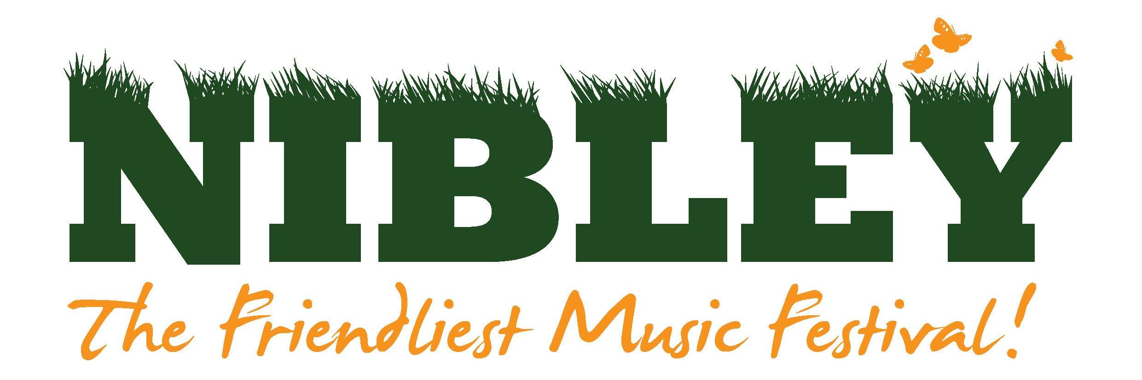
Dear Stallholder,

We are back !!! and look forward to your participation at this year’s festival:
Friday 1st to Sunday 3rd July 2022 at Nibley House Farm
North Nibley, Gloucestershire, GL11 6DL

We are a family festival and our main aim is to provide great music, food and entertainment in a friendly and safe environment. Any profit from the festival is donated to charity.

The theme for 2022 is The Movies and it would be great if you could decorate your stall to suit the theme.

Please take the time to read the stallholder’s general information and health and safety guidelines. This will inform you of site access and trading times. Signing below shows your acceptance of them.

Pitch prices:
- 3x3m pitch + 1 adult ticket - £100
- 3x3m pitch + 2 adult tickets - £170

A sensible amount of additional tickets can be purchased at the selling price before the general sale if your application is successful. All tickets are valid for the whole weekend and camping.
Pitch prices also include one free car parking space and any additional can be purchased when applying for additional tickets.

Trading is compulsory for Saturday and optional for Friday however is encouraged as the main site is open and active. If you choose to trade on Friday, your stall must be ready to trade by 4PM for the gates to open at 5PM.

We plan limited activities in The Orchard on Sunday morning so for stall holders based there an option to trade exists.

You are welcome to camp for the duration of the festival although there is an additional charge for live in vehicles.

It is very important that you have a strong, sturdy shelter to trade from. If you require one, we have them to hire for the weekend for £100 (inc VAT) that will be erected ready for you. Please indicate on the application form if this is required.

Please return the application form, to neil_hasson@sky.com, before Friday 11th February 2022.
Due to expected demand and limited space we may not be able to accept all applications for stalls.

To give you a better chance of joining us at Nibley 2022 It is important for us to clearly understand what you will be selling or providing, any stall requirements and the dimensions of your stall.

We have new volunteers in our team so please complete the application form fully even if you have traded with us previously.

Best Wishes,

Neil Hasson
North Nibley Music Festival Committee
neil_hasson@sky.com 0773 8858416

Nibley Festival Stalls Application Form 2022

Name of stall:

Nature of stall and details of merchandise:

Will you provide any interactive elements to your stall? (Please include as much detail as possible) :

Details of Main Contact :

Name
Address
Phone No
Mobile No
Email
Website and / or Facebook

Insurance: Stallholders MUST have public liability insurance. Please supply details. We require proof of insurance with this application, this can be e-mailed or posted alongside this application. Applications will not be considered without it

Please indicate which deal you will require:

3x3m pitch with 1 adult weekend ticket | £100 | Y/N
3x3m pitch with 1 adult weekend ticket | £170 | Y/N
Do you require a live in vehicle pass | £75 | Y/N
Do you wish to hire a 3x3m gazebo | £100 | Y/N

Any other details we may need to know? :

Please advise the type of vehicle you will be bringing to transport your stall :

Would you like to purchase any additional tickets :

Ticket Type | Price | Number Required
Adult (18+) | £85
Accompanied Teen (13-17 years old) | £60
Accompanied Child (4-13 years old) Under 4’s are free | £35
Live in Vehicle (per vehicle) | £75
Car Parking (per car / van) | £10

DO NOT SEND ANY PAYMENT AT THIS POINT. WE WILL INVOICE YOU ONCE YOUR APPLICATION IS APPROVED

I agree to abide by the attached terms and conditions.

Signed:
Print name: Date:

