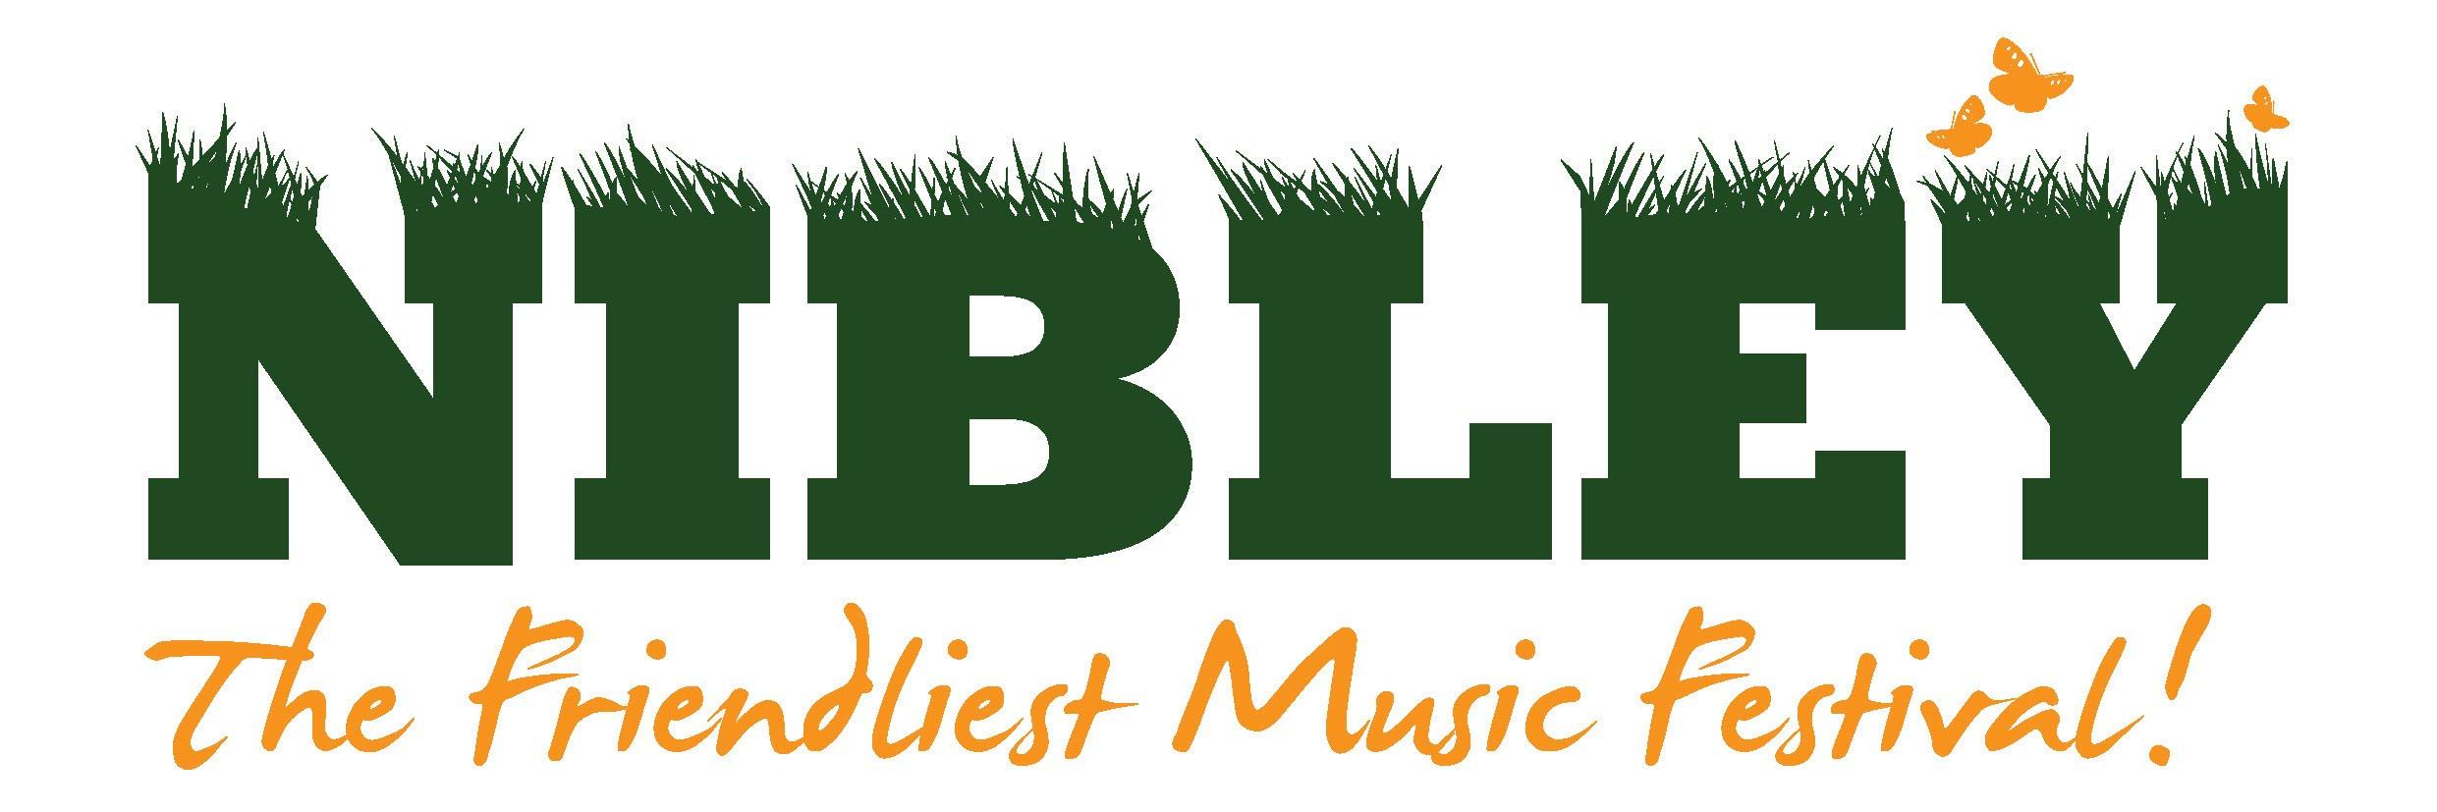
Friday 1st to Sunday 3rd July 2022
GENERAL INFORMATION AND HEALTH & SAFETY GUIDELINES FOR STALLHOLDERS
We look forward to your participation in North Nibley Music Festival 2022. Please take the time to read through these guidelines and discuss any issues you may have with us prior to the event.
Environmental Impact
Nibley Music festival is looking at how we can minimize its impact on the environment. We would appreciate you considering ways that your stall can help us work towards this, for example paper bags, recycling where possible and eco-friendly glitter or gems.
General Information:
- The closing date for applications is Friday 11th February 2022. Offers of pitches will be made after this date but before Friday 11th March.
- Opening Times for traders:
  - Friday 1st July – Optional trade times are 5pm onwards. You must be set up by 4pm to allow for health and safety checks.
  - Saturday 2nd July – 11am onwards for stallholders in the main arena. An earlier start time is possible for stallholders in The Orchard. You must be set up by 10.30am to allow for health and safety checks (Trade stalls must be open until at least 8pm).
  - Sunday 3rd July – up to midday for stalls in The Orchard. Note – the main arena will not be open on Sunday.
Indicative permitted arrival times of traders:
  - Thursday 30th June: (On request)
  - Friday 1st July: 8 am -2 pm
  - Saturday 2nd July: 7 am -9.30 am
We will ask for more details about your arrival much closer to the date.
- If you need vehicular movement on the site during the event this must be agreed in advance and cleared with the festival management before any movement on the day. We are rearranging the layout of the main arena for 2022. This may make vehicular access more difficult during times when the main arena is open.
- There will be a separate area available for trader camping.
- Smoking is prohibited inside any tent or stall.
- No barbecues are to be brought onto the site.
- No alcohol to be brought onto the site.
- No glass bottles, drinking glasses etc are allowed onto the site.
- No amplified music except as agreed with the organisers - we have our own!
- Please keep your stall area free of rubbish and particularly a build up of combustible material. Use the bins and recycling facilities provided. We would appreciate it if you could take home as much of your non-recyclable rubbish as possible.
- Please provide yourselves with some form of overhead shelter from the weather and all tables etc that you require for your stall (see application form for information on renting a shelter from the festival).
- Ensure all stalls or structures used are securely fastened and do not present a trip hazard. The festival site can be windy. Stall holders are responsible to ensure that their structure is robust and adequately secured, in case of severe weather, for stability. Stallholders bringing unsuitable structures onto site will be asked to remove the structures or find a way of securing them to the site in a satisfactory way. The festival organisers take public safety very seriously and if the structures are not deemed to be fit for purpose this could result in the stallholder being unable to trade upon the day.
- The event manager and designated event safety advisor(s) will undertake a brief inspection of all stalls prior to the event commencing.
- There is a supply of potable water on site.
Face painting, Glitter & Henna
- Details of the contents of the paints/henna must be provided to us before trading begins.
- Please ensure that majority of glitter is eco friendly. Stalls will only be accepted on this basis.
Insurance:
- Stallholders must have public liability insurance. We recommend £5million minimum, however we will consider lower. Please contact us to discuss. Evidence must have been provided when applying. We may also ask for a further copy closer to the date to ensure that the insurance is in date for the festival.
Security and Payment:
- Keep cash tins out of sight.
- Security industry authority licensed security personnel are on duty during the event. If you have any security concerns during the event, please contact them or a festival steward.
- We are currently exploring how we can make Nibley a more cashless event. Its unlikely we will be totally cashless but we are hopeful we will have a reliable and robust WIFI in place for traders to use.
Payment:
PLEASE DO NOT SEND ANY PAYMENT AT THIS STAGE. If your application is successful, then we will contact you from mid March with details of how to pay.
Please note that you are welcome to stay and enjoy the rest of the festival after the stalls close.

